בדיקות חומרה
- HLK LD2451 Sensor Test
As part of the hardware validation process, the HLK LD2451 sensor was tested independently before being connected to the ESP32 controller.
The sensor was connected to an external laboratory power supply with an input voltage of 5V. For the initial test, the current limit was set to 20mA, and the trigger output pin OT1 was measured using a multimeter.
During the test, it was verified that the sensor produced a trigger signal of approximately 3V on the OT1 output pin when detection occurred. This confirmed that the sensor was powered correctly and that its digital output signal is suitable for connection to a GPIO input pin of the controller.
A shorter version:
The HLK LD2451 sensor was tested using an external power supply set to 5V with a current limit of 20mA. The OT1 trigger output was measured, and during detection an output voltage of approximately 3V was observed. This confirmed that the sensor operates correctly and provides a digital trigger signal suitable for the ESP32 GPIO input.
- Pir grove:
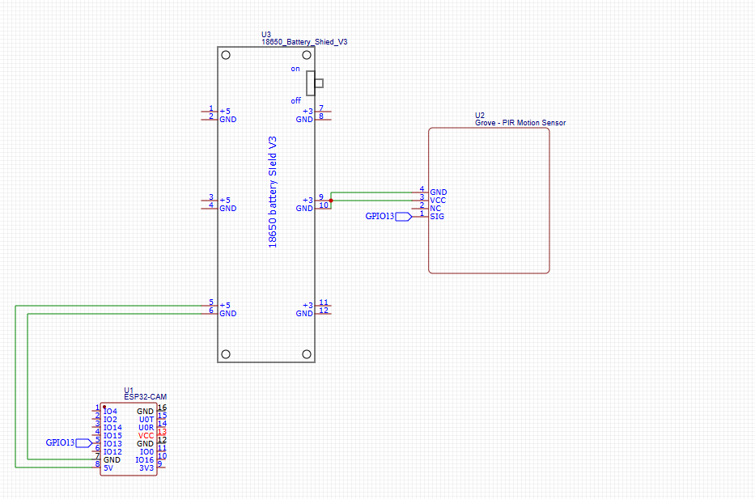
- Battery Module:

